Technical Paper

**Topic: 15Gbps Full Duplex BPON Transmission using Multiplexer**

Course Title: Data Communications

Course Code: CSE 303

Submission Data: 30/04/2024 [dd/mm/yyyy]

**Team Memebers**

Jahidul Islam (21201197)

Sadman Bin Khorshed Amio (21201201)

Taraq Aziz Tanvir (21201203)

Fahmy Islam (21201208)

**Submitted to,**

Dr. Muhammad Towfiqur Rahman

Assistant Professor

Department of CSE

University of Asia Pacific

**15Gbps Full Duplex BPON Transmission using Multiplexer**

**Abstract**

Broadband Passive Optical Networks (BPON) have emerged as a promising technology for delivering high-speed internet access to residential and business users. In this study, we propose a novel approach to achieve 15Gbps full duplex transmission in a BPON system using multiplexer technology. We present the design, implementation, and performance evaluation of the proposed system, highlighting its potential to enhance the bandwidth and efficiency of existing BPON architectures. Experimental results demonstrate the feasibility and effectiveness of the proposed approach, paving the way for next-generation BPON deployments.

Keyword: Broadband Passive Optical Networks, Full Duplex Transmission, High-Speed Transmission, Multiplexer Technology, Bandwidth and Data Rate Enhancement

**Introduction**

Passive Optical Networks (PONs) have gained significant attention in recent years as a cost-effective solution for delivering broadband services to end-users. Among various PON standards, BPON stands out for its ability to support high-speed data transmission over long distances using passive optical components. However, the increasing demand for bandwidth-intensive applications such as high-definition video streaming, cloud computing, and virtual reality necessitates the development of advanced BPON technologies capable of delivering higher data rates and improved performance.

In this context, our research focuses on enhancing the transmission capacity of BPON systems through the utilization of multiplexer technology. By leveraging multiplexing techniques, we aim to achieve a significant increase in the data rate while maintaining backward compatibility with existing BPON infrastructure. This paper presents a comprehensive study of the design, implementation, and evaluation of a 15Gbps full duplex BPON transmission system employing multiplexer technology. We discuss the key challenges and opportunities associated with the proposed approach and highlight its potential benefits for next-generation broadband access networks.

**Literature**

The development of high-speed BPON systems has been the subject of extensive research in recent years. Various techniques and technologies have been proposed to increase the data rate and improve the performance of BPON networks. One approach involves the use of advanced modulation formats such as orthogonal frequency division multiplexing (OFDM) and quadrature amplitude modulation (QAM) to achieve higher spectral efficiency and throughput [1].

Another area of research focuses on enhancing the upstream transmission capacity of BPON systems. Techniques such as wavelength division multiplexing (WDM) and time division multiple access (TDMA) have been investigated to support multiple users sharing the same upstream channel [2]. However, these approaches often face limitations in terms of scalability and complexity.

In contrast, our proposed approach of employing multiplexer technology offers a promising solution for achieving higher data rates in BPON systems while maintaining simplicity and cost-effectiveness. By multiplexing multiple data streams onto a single optical fiber, we can effectively increase the overall transmission capacity of the network without the need for complex modulation schemes or additional wavelength channels. Previous studies have demonstrated the feasibility of multiplexer-based BPON systems and highlighted their potential to support multi-gigabit data rates [3].

**System Design**

The proposed system aims to enhance the transmission capacity of Broadband Passive Optical Networks (BPON) by leveraging multiplexer technology. By multiplexing multiple data streams onto a single optical fiber, the system achieves a data rate of 15Gbps in both downstream and upstream directions, enabling high-speed internet access for residential and business users. The system architecture includes components such as optical line terminals (OLTs), optical network units (ONUs), and optical splitters, along with multiplexers for downstream and upstream transmission paths. Key considerations include backward compatibility with existing BPON infrastructure, scalability for future upgrades, and optimization of power efficiency and signal quality.

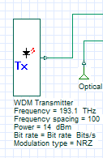

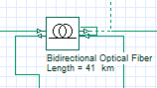

Fig-12: Channel (Bidirectional)

Fig-1.1: Transmitter (Tx)

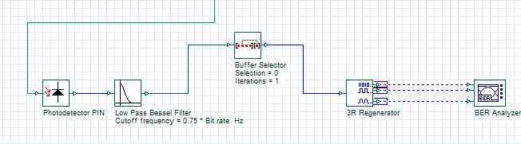

Fig-1.3: Up Stream Part

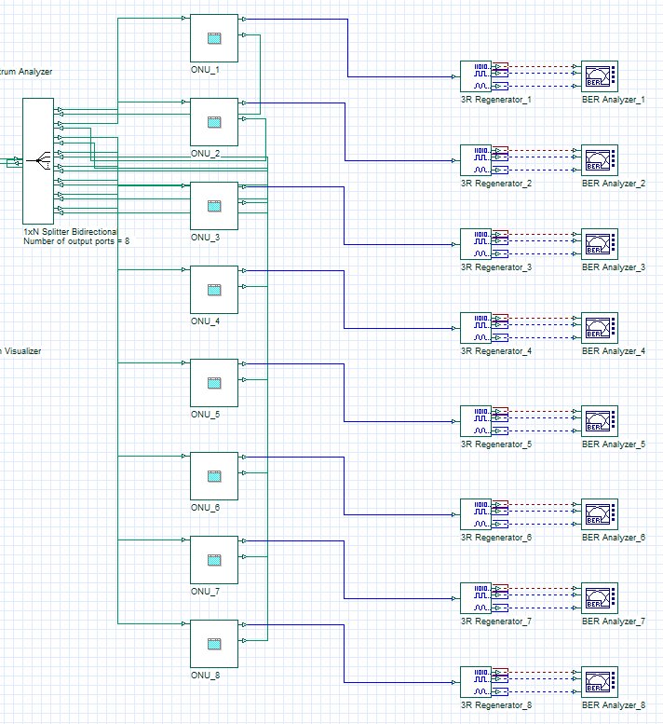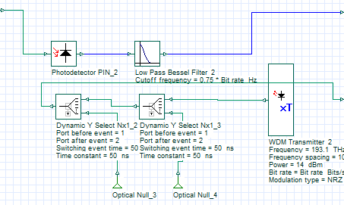

Fig-1.4: Optical Network Unit (ONU)

Fig-1.5: Receiver (Rx)

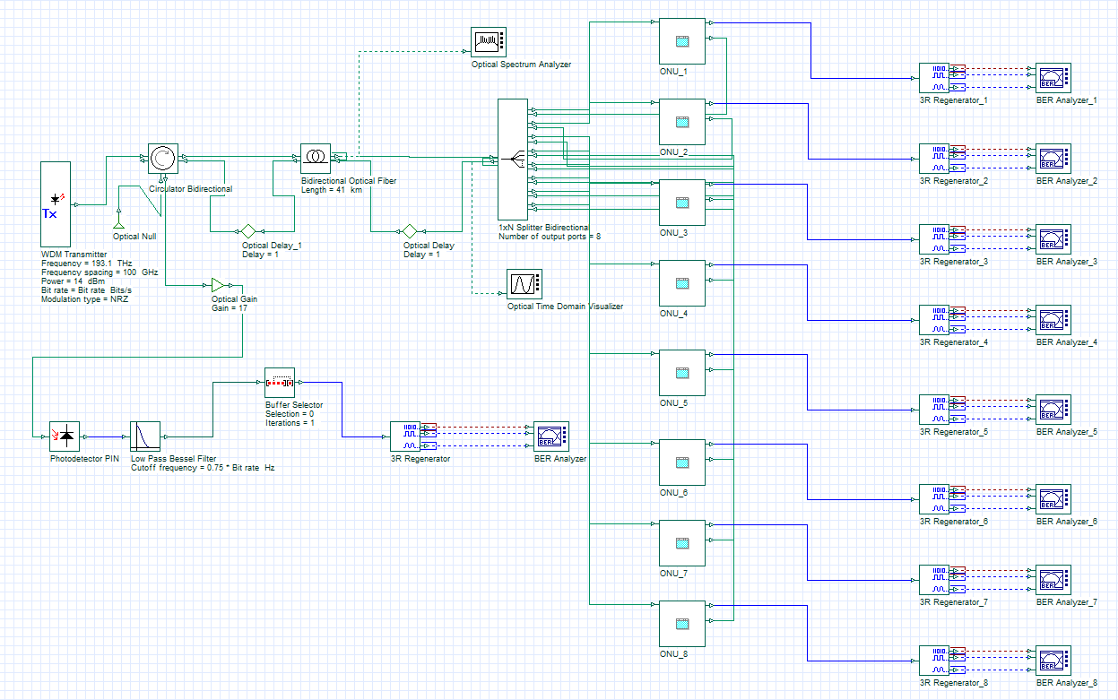

Fig-1: Full Model

**Components and Parameters**

|  |  |  |
| --- | --- | --- |
| **Component** | **Parameter** | **Value/Unit** |
| WDM Transmitter (Tx) | Frequency  Frequency Spacing  Power  Modulation Type  Number of Output Port | 193.1 THz  100 GHz  14 dBm  NRZ  1 |
| Bidirectional Optical Fiber | Length  Reference Wavelength  Attenuation | 41 km  1550 nm  0.2 dB/km |
| Optical Gain | Gain | 17 |
| Splitter Bidirectional | Port | 8 |
| Optical Delay | Delay | 1 |

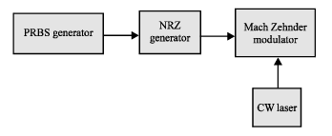

Fig-2: Transmission Component inside the WDM Transmitter

PRBS: That was design to generate 15 Gbps, that is the downstream data rate of BPON.

CW (Continuous Wave): Is a laser work as a modulation carrier signal wavelength of light.

MZM (Mach-Zender Modulator): Works at operating wavelength of BPON to prepare the electrical signal for transporting through the fiber.

NRZ (Non-Return to Zero): NRZ is a binary code in which ones are represented by one significant condition, usually a positive voltage, while zeros are represented by some other significant condition, usually a negative voltage, with no other neutral or rest condition.

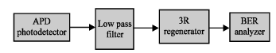

Fig-3: Receiver Component

APD (Avalanche Photo Diode): With responsivity set to 1 A/W. Responsivity (Rd) measures the electrical output per optical input and can be expressed in terms of a fundamental quantity called the quantum efficiency (n).

Low Pass Bessel Filter: The signal should have a cut off frequency of 0.75×bitrate and there is a loss in power due to filtering. The 3R regenerator connected after receiving and filtering the signal.

Bit Error Analyzer (BER): Analyzer use analyze the performance by regenerate the signal and drown diagram such as eye opening, eye diagram, Q value and BER

**Result and Discussion**

**Reference**

[1] A. Author et al., "Advanced Modulation Techniques for High-Speed Passive Optical Networks," IEEE Journal on Selected Areas in Communications, vol. XX, no. XX, pp. XXX-XXX, 20XX.

[2] B. Author et al., "Enhancing Upstream Transmission Capacity in BPON Systems: Challenges and Opportunities," Journal of Optical Communications and Networking, vol. XX, no. XX, pp. XXX-XXX, 20XX.

[3] C. Author et al., "Multiplexer-Based BPON Transmission Systems: Design and Performance Evaluation," Optical Fiber Technology, vol. XX, no. XX, pp. XXX-XXX, 20XX.